S.No | Name | Designation | Qualification | Faculty Id | PHOTO
 | Dr. RAJU MERUGU | Professor | M.PHARMACY,Ph.D | 3495-180201-150702 | 
 | SRILATHA MANUPATI | Assistant Professor | M.PHARMACY | 60150404-182613 | 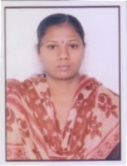
 | RACHAKONDA NARMADA | Assistant Professor | M.PHARMACY | 9453-150409-172156 | 
 | SRIRAMOJU SHILPA | Assistant Professor | M.PHARMACY | 8481-150409-230059 | 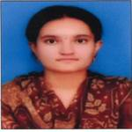
 | THATIPALLY RAJESHWAR | Assistant Professor | M.PHARMACY | 0100-150410-014047 | 
 | CHATLA HEMALATHA | Assistant Professor | M.PHARMACY | 3125-150414-140430 | 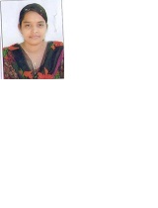
 | MADHURI POLA | Associate Professor | M.PHARMACY | 1448-150414-141458 | 
 | VIKRAM TATIPAMULA | Assistant Professor | MCA COMPUTERS | 7150-150420-144506 | 
 | GANGIPELLI SHIVA KUMAR | Assistant Professor | M.PHARMACY | 6555-160204-140410 | 
 | EERLA SRILATHA | Assistant Professor | M.PHARMACY | 3164-160216-153732 | 
 | BATHINI SRIKANTH | Assistant Professor | M.PHARMACY | 7962-160305-143343 | 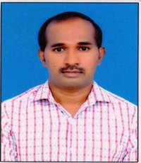
 | SIDDIPETA POOJA | Assistant Professor | M.PHARMACY | 9074-160306-091450 | 
 | RENIKUNTA DIVYABHARATHI | Assistant Professor | M.PHARMACY | 7302-160527-194552 | 
 | BANDI SOUMYA | Assistant Professor | M.PHARMACY | 1819-170127-120540 | 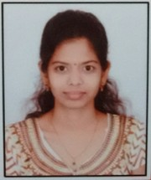
 | NAGULA SESHAGIRIDHARBABU | Assistant Professor | M.PHARMACY | 5378-170131-185849 | 
 | BHOOKYA RAJU | Assistant Professor | M.PHARMACY | 1448-170131-200928 | 
 | KOMMERA SINDHUJA | Assistant Professor | M.PHARMACY | 9015-170202-130415 | 
 | MANDALA SUPRIYA | Assistant Professor | M.PHARMACY | 5696-170203-115252 | 
 | YERROLLA RAGHAVENDRA | Assistant Professor | M.PHARMACY | 8800-171227-170428 | 
 | KANDULA GOWARDHAN | Assistant Professor | M.PHARMACY | 9328-171227-172138 | 
 | NEELI BHAVANA | Assistant Professor | M.PHARMACY | 5528-180111-103141 | 
 | GAJARLA RADHAKRISHNA | Assistant Professor | M.PHARMACY | 8709-180130-190354 | 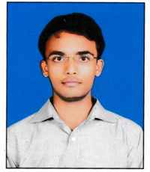
 | GUDDAM MOUNIKA | Assistant Professor | M.PHARMACY | 0778-190111-130417 | 
 | CHYTANYA JANNAVARAM | Others | M.A- ENGLISH | 8742-190111-144121 | 
 | NANDIKONDA JEEVITHA | Assistant Professor | M.PHARMACY | 9350-190220-172306 | 
 | THATIPELLI ARCHANA | Assistant Professor | PHARM.D | 4792-190430-153917 | 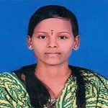
 | EJJAGIRI LAVANYA | Assistant Professor | M.PHARMACY | 4515-190506-115411 | 
 | VIDHYA SREE MANTHANA | Assistant Professor | M.PHARMACY | 1624-191108-135833 | 
 | MUHAMMAD TAUHEED MUHAMMAD TAUHEED | Assistant Professor | M.PHARMACY | 2250-191113-143556 | 
 | SHALOM MANNE | Assistant Professor | PHARM.D | 9180-200304-124754 | 
 | NAZIYA KHATOON NAZIYA KHATOON | Assistant Professor | M.PHARMACY | 5417-200304-142903 | 
 | JHANSI DHARAVATH | Assistant Professor | M.PHARMACY | 2637-200307-174437 | 
 | AMANI REDDY GUDA | Assistant Professor | M.PHARMACY | 9878-200307-175840 | 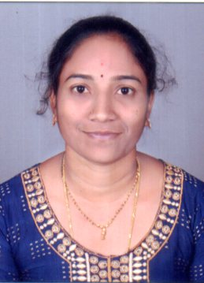
 | L.SUJATHA | Assistant Professor | M.PHARMACY | 3624-150409-132438 | 